Toy Model #1

$$Simple: \frac{dΦ}{dt}=Aβcos\left(αβt\right)$$

$$Diffusion: \frac{dΦ}{dt}=D\frac{d^{2}Φ}{{dx}^{2}}+ Aβcos\left(αβt\right)$$

# Results Simple

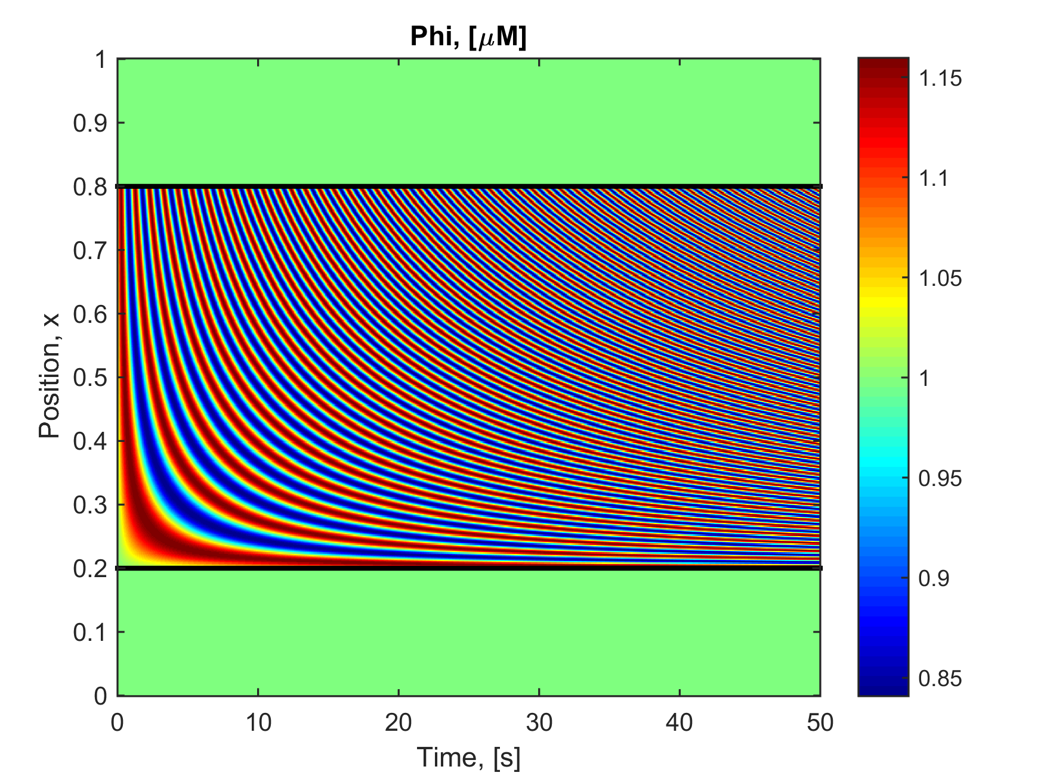

Figure 1

# Results Diffusion

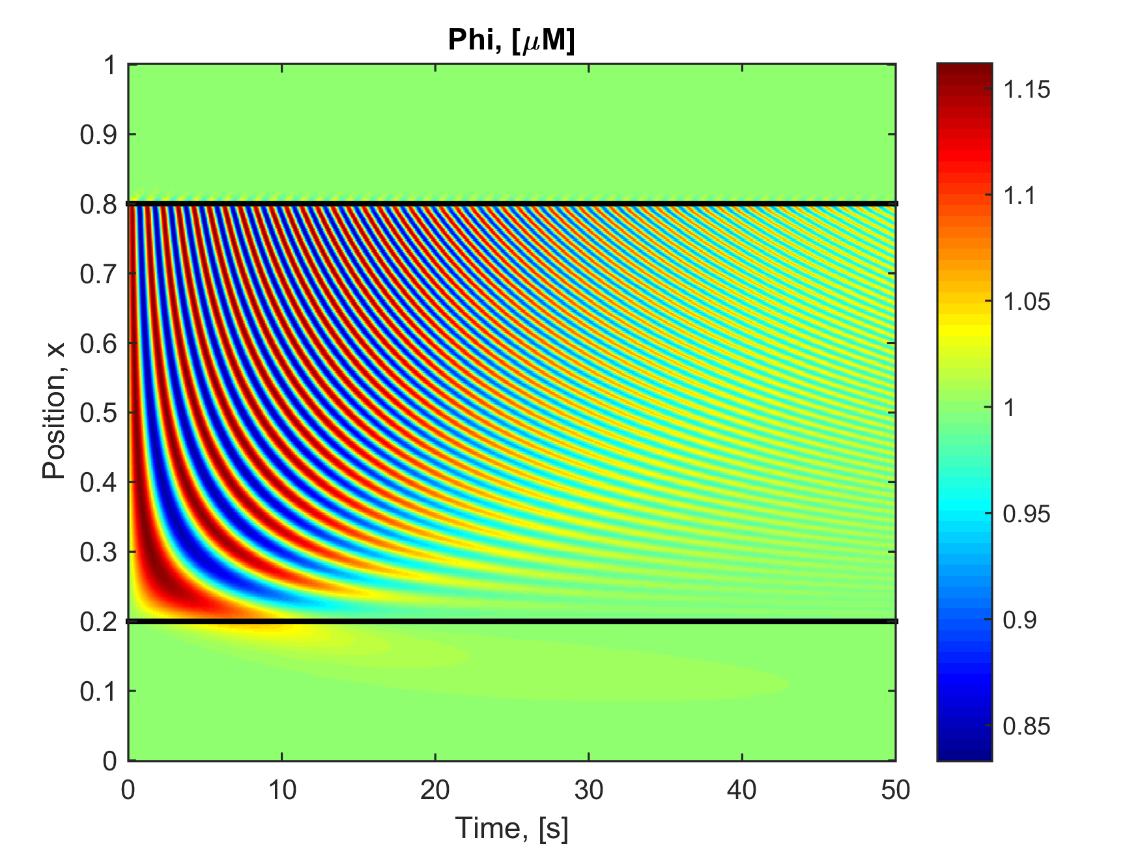

Figure 2

# Period Map: Simple

Note that the period is constant over time and only varies over x

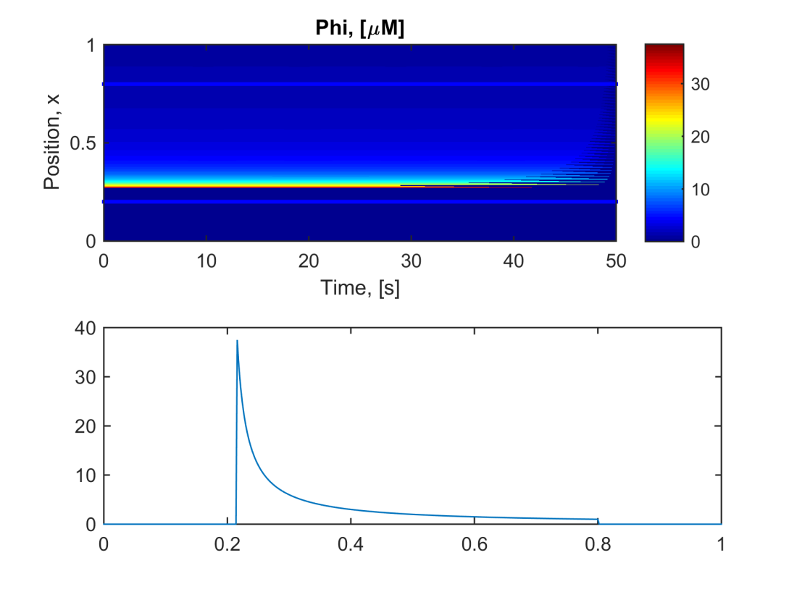

Figure 3 & 4

# Period Map: Diffusion

Note the blue jagered line is added after and denotes the minimum period points: Continue reading to understand.

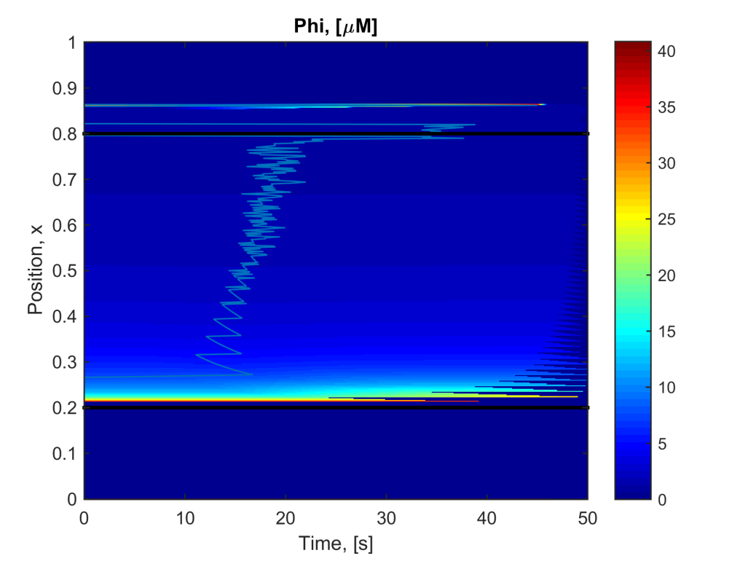

Figure 5

# Three x points: Solution

The solution is plotted for x = {0.6, 0.5, 0.3} respectively where blue is the simple and red is diffusion. This shows that over time the concentration will stop oscillating in the diffusion case to the initial value.

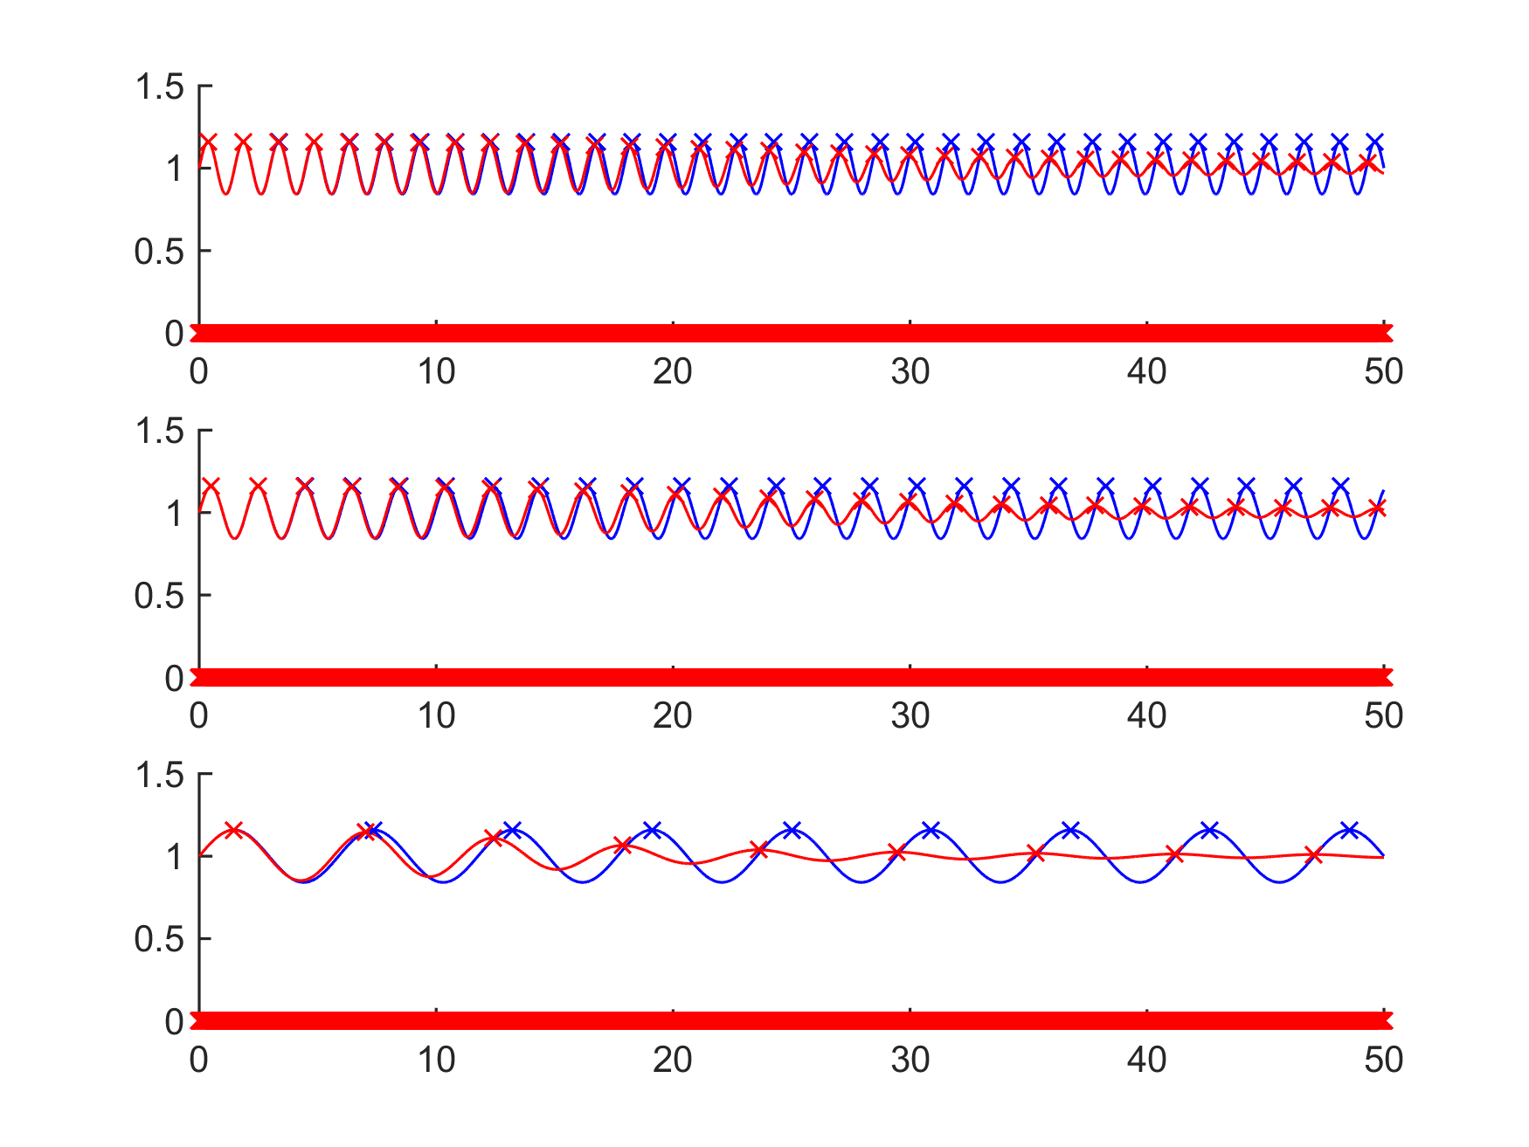

Figure 6

# Three x points: Period

Plotting the period of the same three points shows that the period decreases then increases back to the same period. This min point was then plotted on figure 5. Note that the period plot is not smooth so the minimum point is not exact hence the jiggered line on figure 5.

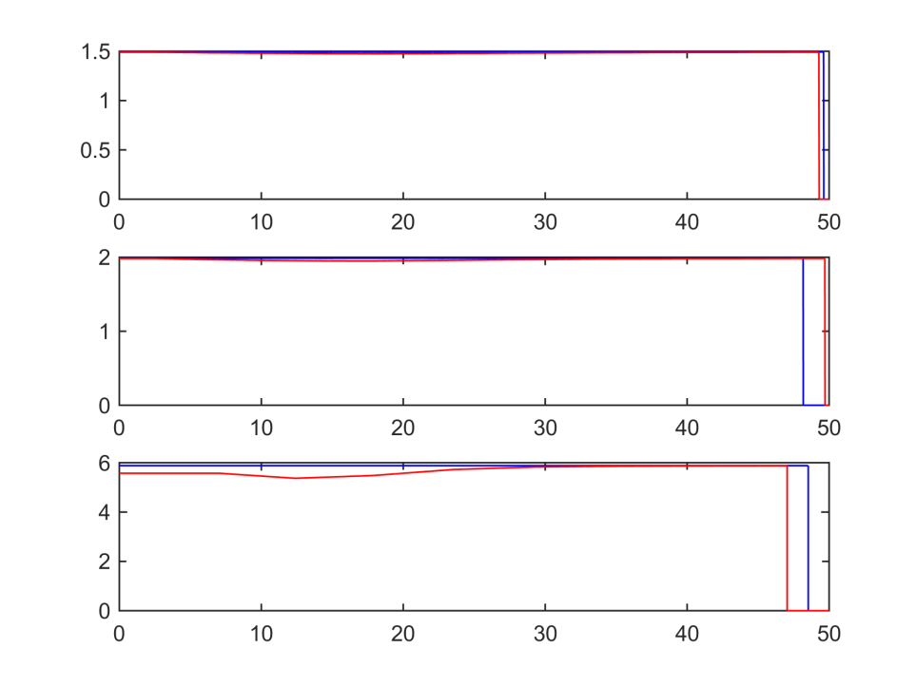

Figure 7